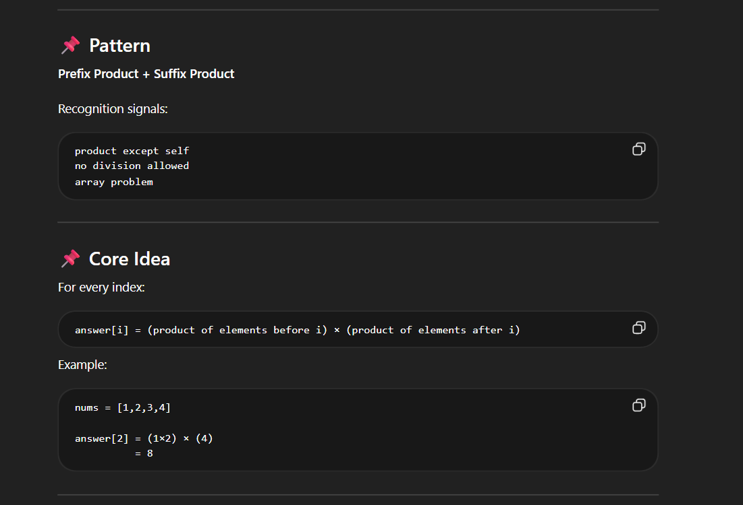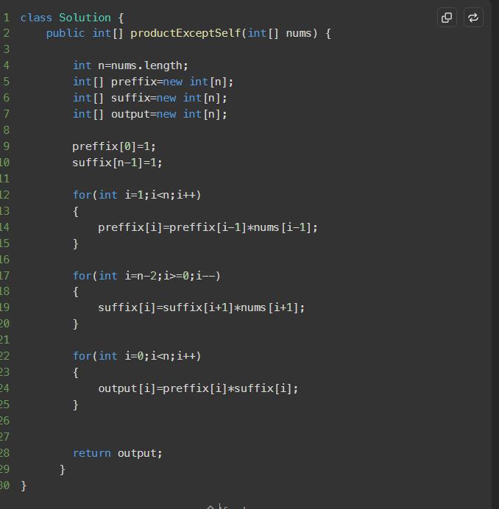

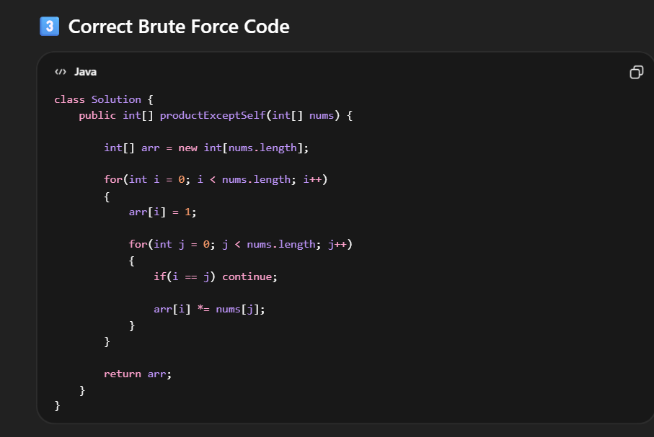

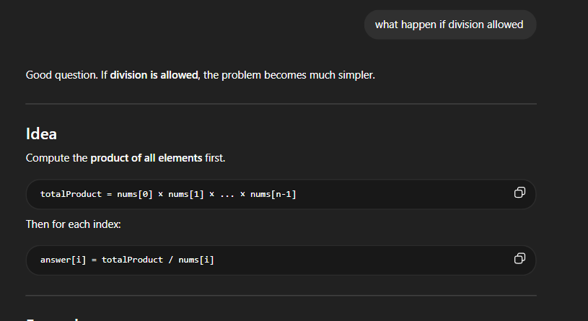
IF DIVISION IS ALLOWED THE CODE IS ::::
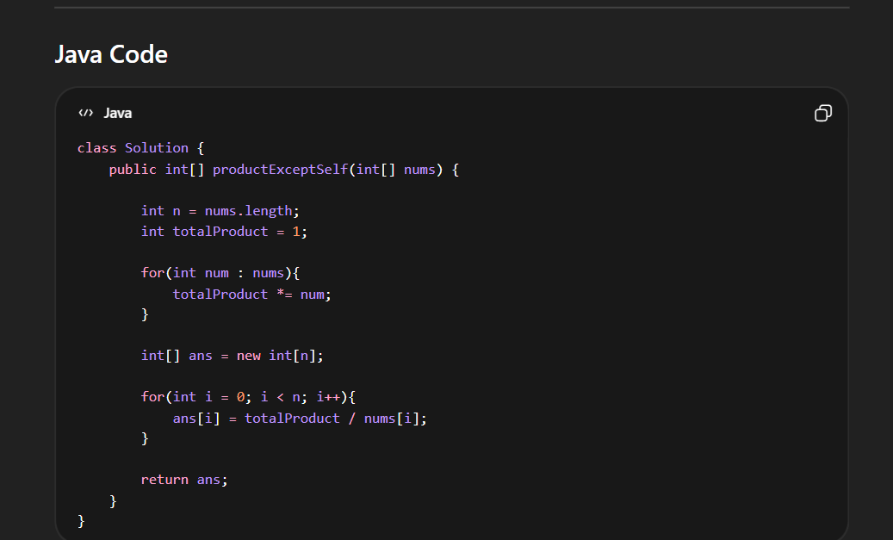

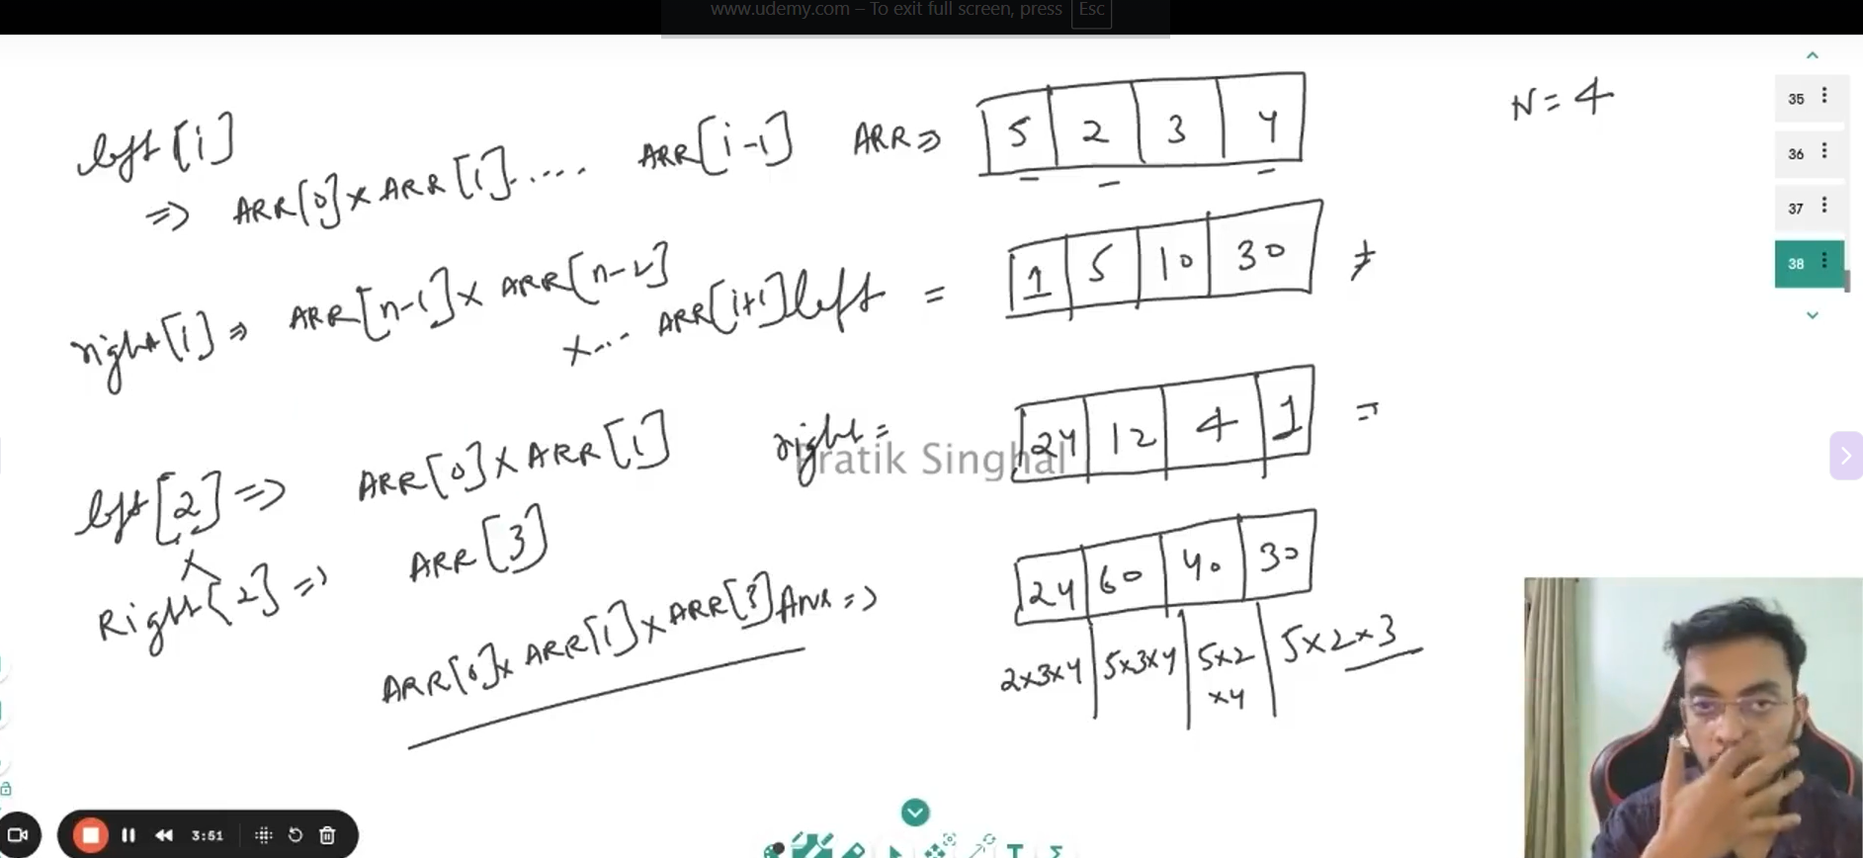

FIRST HAVE PREFIX AND SUFFIX ARRAY WITH FIRST ELEMNT OF PREFFIX AS ONE AND LAST ELEMNT OF SUFFIZ AS ONE ( BECAUSE THE PREFIX OF FIRST NUMBER DOESN’T EXIST) …
THEN FOR EACH NUMBER HAVE PREFIX MULTIPLIED AND STORED IN ARRAY …

SPACE COMPLEXITY O(1)
